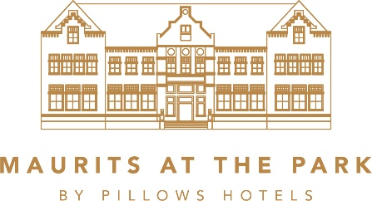
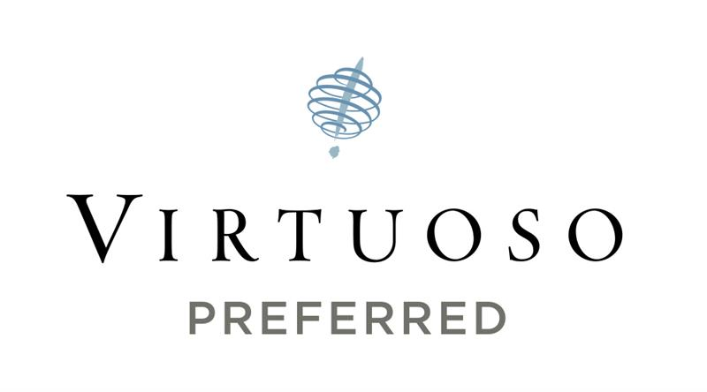
PILLOWS HOTEL MAURITS AT THE PARK ACCEPTED INTO GLOBAL LUXURY TRAVEL GROUP VIRTUOSO

AMSTERDAM, NETHERLANDS (July 6, 2026) – Pillows Hotel Maurits at the Park has been accepted into Virtuoso’s exclusive portfolio of luxury travel partners, comprising 2,800 preferred suppliers in 100 countries. According to Mascha Ligthart, CEO of Pillows Hotels Maurits at the Park, inclusion in Virtuoso will present new sales and marketing opportunities to the network’s luxury travel advisors and their highly desirable clientele. Virtuoso agencies worldwide sell an average of (U.S.) $35 billion annually, making the network the most significant player in luxury travel.

“Virtuoso’s acceptance process is incredibly selective, so becoming a preferred partner is a true honor,” said Ligthart. “The reputation Virtuoso member agencies have for outstanding dedication to their clients is a perfect fit with our own bespoke approach to service. Now that we’re part of this renowned network, we look forward to offering Virtuoso advisors and their clients the special amenities, values and experiences that surpass their expectations.”

Pillows Hotel Maurits at the Park joins Virtuoso’s collection of the finest luxury hotels, resorts, cruise lines, airlines, tour operators and other travel entities worldwide. These partners, which specialize in world-class client service and experiences, provide superior offerings, rare opportunities and exceptional value for Virtuoso clients. These prestigious providers are able to market to Virtuoso clients via network vehicles and to Virtuoso agencies through multiple communications channels and events, including Virtuoso Travel Week, luxury travel’s preeminent worldwide gathering. Pillows Hotel Maurits at the Park’s acceptance into Virtuoso gives it direct relationships with the world’s leading leisure travel agencies in North and Latin America, the Caribbean, Europe, Asia-Pacific, Africa and the Middle East.

Set within a landmark university building from 1908, between the green Oosterpark and Amsterdam’s UNESCO-listed canals, Pillows Hotel Maurits at the Park offers a refined Amsterdam experience where history, art and contemporary luxury come together. The 88-room hotel combines elegant accommodations with exceptional culinary experiences, including fine dining at VanOost Restaurant, all-day dining at Spring Café Brasserie and award-winning cocktails at Fitz’s Bar. From its private jetty, guests can step directly onto the canals for a tailor-made boat experience arranged by the Les Clefs d’Or concierge team. With a guest-only living space, curated art throughout the hotel and thoughtful attention to every detail, Pillows Maurits at the Park creates memorable stays for discerning travelers. Guests of Virtuoso member agencies enjoy exclusive benefits, including a room upgrade upon availability, daily breakfast, hotel credit and the flexibility of early check-in or late check-out, subject to availability, creating an experience tailored to every stay.

For more information about Pillows Hotel Maurits at the Park, call +31 20 80 202 00 or visit Pillows Hotel Maurits at the Park.

About Pillows Hotels
Pillows Hotels is a collection of luxury boutique hotels in the Netherlands and Belgium. Set within carefully restored historic buildings, each hotel combines elegant design, refined hospitality and exceptional culinary experiences, creating memorable stays for discerning travelers.

Personal service, attention to detail and a strong sense of place define every Pillows destination. The collection is consistently recognized by leading travel and culinary guides, with hotels, restaurants and bars featured by Michelin, Gault&Millau and Tripadvisor. In Michelin Guide's first global hotel selection, three of the six Pillows Hotels were awarded Michelin Keys, including Pillows Hotel Maurits at the Park in Amsterdam with Two Michelin Keys, Pillows Grand Boutique Hotel Ter Borch in Zwolle with One Michelin Key and Pillows Grand Boutique Hotel Reylof in Ghent with One Michelin Key.
About Virtuoso
Virtuoso is the leading global travel agency network specializing in luxury and experiential travel. This by-invitation-only organization comprises over 1,200 travel agency locations with more than 20,000 travel advisors in 58 countries throughout North America, Latin America, the Caribbean, Europe, Asia-Pacific, Africa and the Middle East. Drawing upon its preferred relationships with 2,800 of the world’s best hotels and resorts, cruise lines, airlines, tour companies and premier destinations, the network provides its upscale clientele with exclusive amenities, rare experiences and privileged access. Annual sales of (U.S.) $35 billion make Virtuoso a powerhouse in the luxury travel industry. For more information, visit www.virtuoso.com.

# # #

Media Contacts: Joke-Jiers Botma
Brand & PR Specialist
Pillows Hotels
Phone: +31 85 487 20 00
Email: press@pillowshotels.com

Misty Belles
Vice President, Global Public Relations
Virtuoso
Phone: +1.202.553.8817
Email: mbelles@virtuoso.com

Travel Trade Contact: Alicja Koopman
Director of Sales
Pillows Hotel Maurits at the Park
Phone: +31 651 88 35 10
Email: alicja.koopman@pillowshotels.com

